The title of my contribution

A. Author^{1,2}, B. Author², C. Author² and D. Author ¹
¹Affiliation, Region, Country
²Affiliation, Region, Country
Email: (presenter's email address)

Please insert the abstract body here. Please insert the abstract body here. Please insert the abstract body here. Please insert the abstract body here. Please insert the abstract body here. Please insert the abstract body here. Please insert the abstract body here. Please insert the abstract body here. Please insert the abstract body here. Figure is optional…

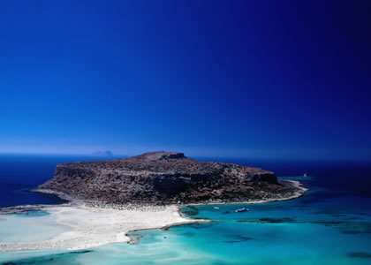
Figure 1. Figure caption here

Please insert the abstract body here [1]. Please insert the abstract body here [2]. Please insert the abstract body here. Please insert the abstract body here [3]. Please insert the abstract body here.

[1] A. Author et al., Phys. Rev. Lett., 99, 11111 (2013)
[2] A. Author et al., Phys. Rev. Lett., 99, 11111 (2013)
[3] A. Author et al., Phys. Rev. Lett., 99, 11111 (2013)

